Secure Networks With Firewalls NAT, Port Filtering and other methods
Tasks

1. Set up Windows Defender Firewall on your Windows laptop or PC and create a new inbound rule to block all incoming traffic on port 8080. Take a screenshot of the rule you created.

Windows Defender Firewall - Block Inbound Port 8080

Objective:
To configure an Inbound Rule in Windows Defender Firewall with Advanced Security to restrict and block all incoming network traffic requesting access via TCP Port 8080.

Step-by-Step Implementation Procedure:
- Open Firewall Management Console: Press Windows + R, type wf.msc, and press Enter to open Windows Defender Firewall with Advanced Security.
- Create New Inbound Rule: Click on Inbound Rules in the left-hand pane, then click New Rule... in the right Actions pane.
- Select Rule Type & Port: Choose Port, click Next, select TCP, and enter 8080 under Specific local ports.
- Configure Action: Select Block the connection and click Next.
- Apply Profiles & Name Rule: Ensure all profiles (Domain, Private, Public) are checked, assign the name Block_Port_8080, and click Finish.

Configuration Summary & Proof:
- Rule Name: Block_Port_8080
- Rule Type: Inbound Rule (Port-based)
- Protocol & Port: TCP, Port 8080
- Action: Block the connection
- Status: Enabled (Active)

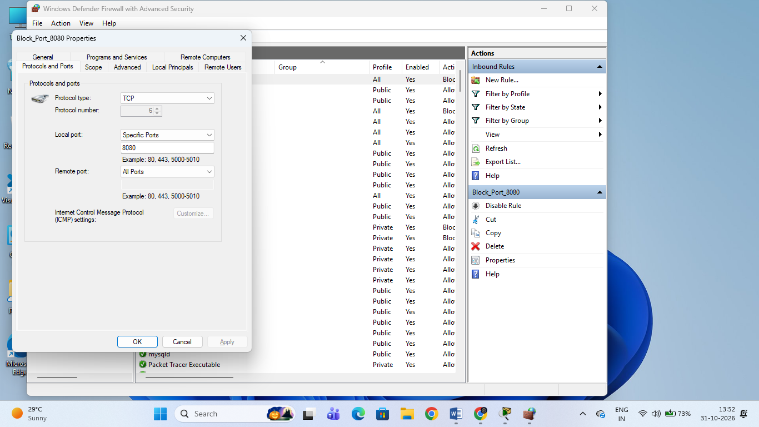

2. Simulate NAT (Network Address Translation) by drawing a simple diagram showing how your home WiFi router assigns private IP addresses to your phone, laptop, and smart TV, and how it translates them to a single public IP for internet access. Use any drawing tool or even hand-draw and click a photo.

NAT (Network Address Translation) Simulation Report

1. Objective & Explanation
- Overview: To simulate how a home wireless router assigns private IP addresses to local network devices (PC, Laptop, Smartphone) and uses NAT (Network Address Translation) to translate them into a single public IP for external communication.
- Working: Local devices operate on private subnet ranges behind the WRT300N Wireless Router. When accessing the local web server ([http://192.168.1.100](http://192.168.1.100)), the router handles internal routing and packet forwarding.

2. Practical Screenshots & Proof
- Figure 1: Network Topology Setup
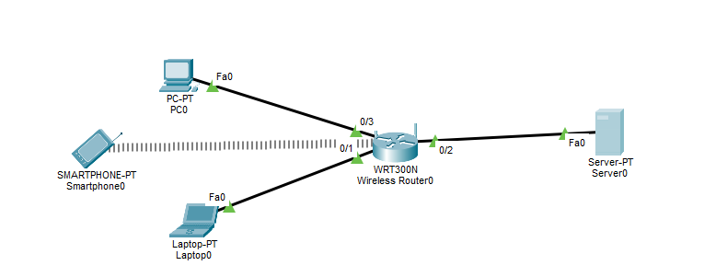Description: WRT300N Wireless Router connected with PC0, Laptop0, Smartphone0, and Server0.
- Figure 2: Router Configuration
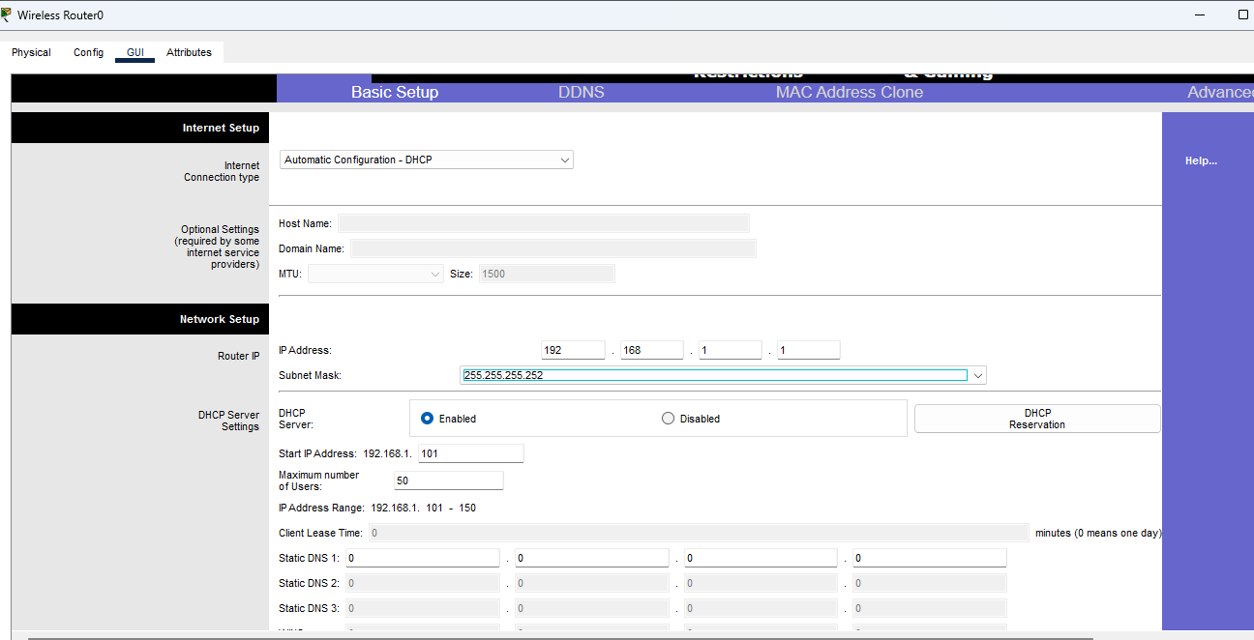
Description: Router IP configured as 192.168.1.1 with DHCP server enabled for local IP assignment.

- Figure 3: Client IP Configuration
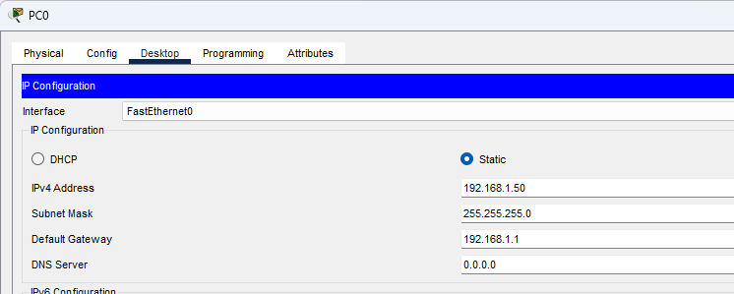
Description: Static IPv4 configuration set on PC0 (192.168.1.50) matching the router gateway 192.168.1.1.
- Figure 4: Successful Web Server Access (NAT Simulation Output)
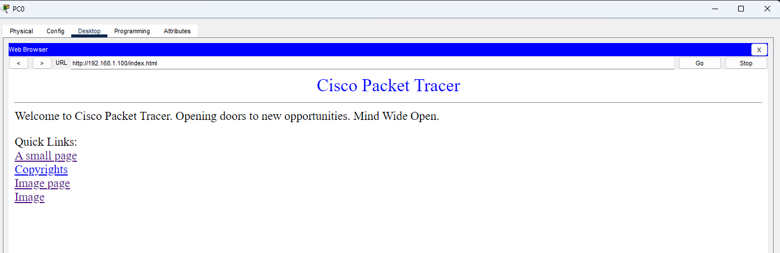
Description: Cisco Packet Tracer default web page successfully loaded from the server via (http://192.168.1.100)

3. Configure port filtering using your WiFi router's admin panel (or use a router simulator online if you don't have access). Block outgoing traffic on port 25 (SMTP) and explain in 2 sentences how this could help prevent spam from your network.

Port Filtering Configuration & Explanation

1. Configuration Steps
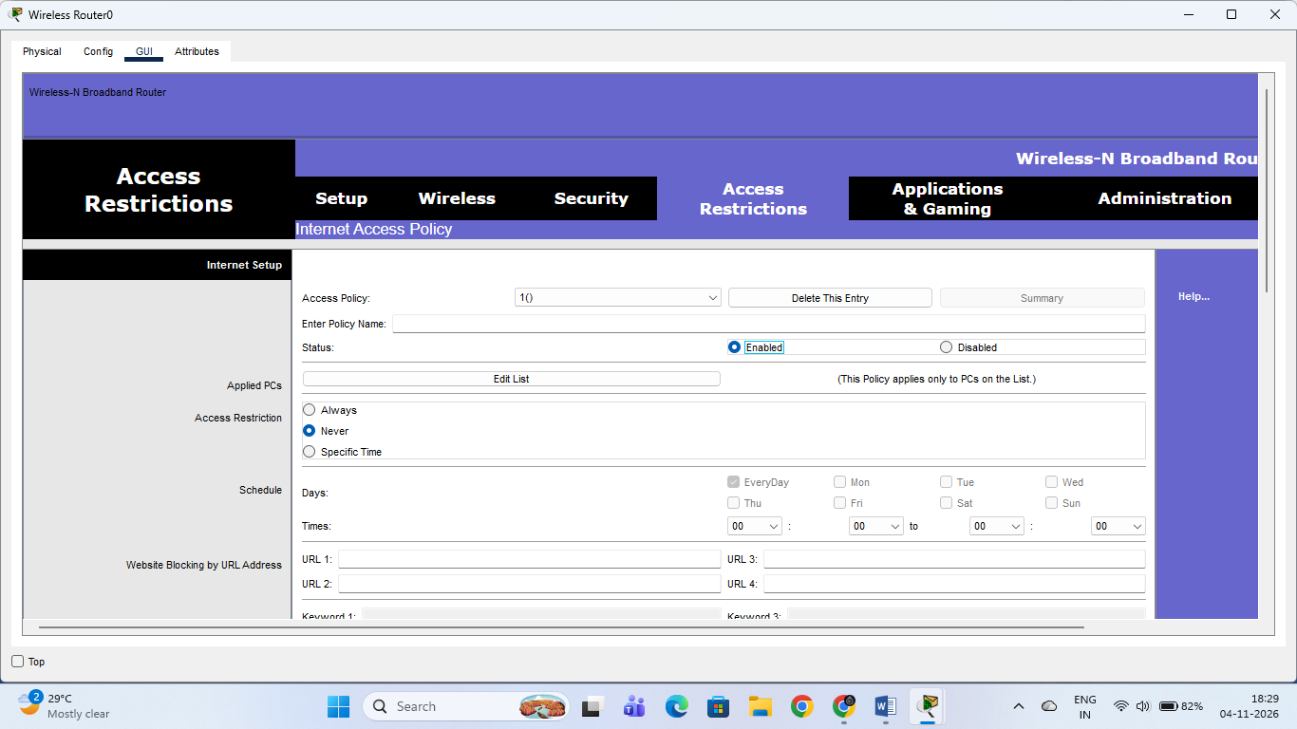
2. Practical Screenshot

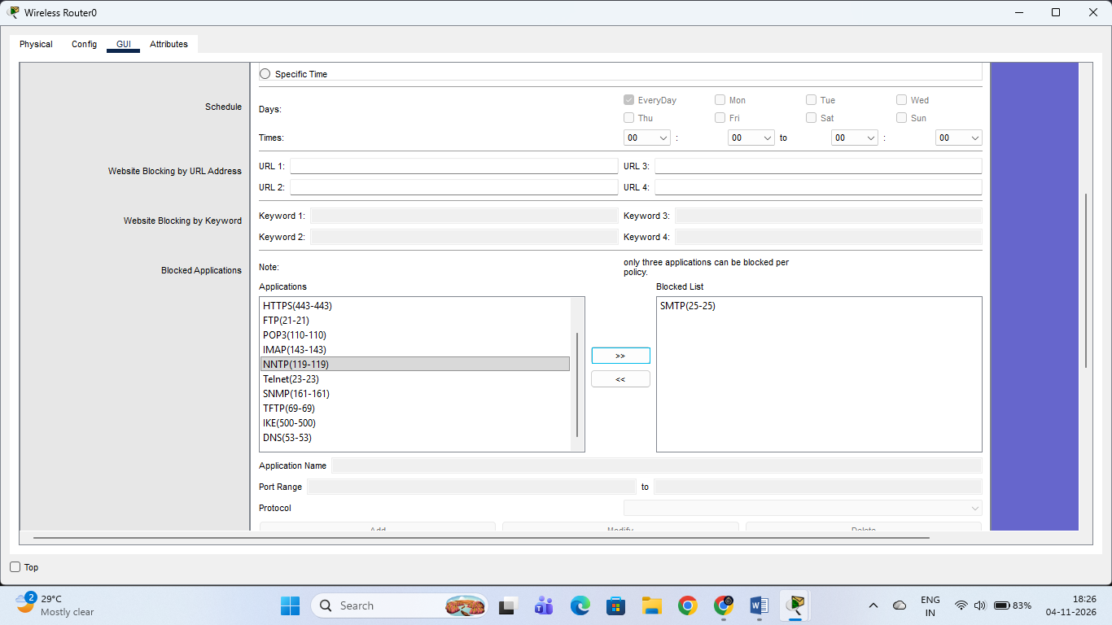

3. Explanation (Spam Prevention)
Blocking outgoing traffic on port 25 prevents unauthorized applications or compromised devices on your local network from sending direct, unencrypted emails through the standard SMTP protocol. This helps stop malicious botnets or malware from using your network to distribute bulk spam emails, protecting your public IP address from getting blacklisted.
4. Given a sample packet filtering rule set (provided by your trainer), identify which of these three sample packets would be allowed or blocked: 1) HTTP request from 192.168.1.5 to 172.217.166.78:80, 2) SSH request from 10.0.0.10 to 34.201.23.1:22, 3) DNS query from 192.168.1.7 to 8.8.8.8:53. Focus on source/destination IPs and ports in the rule set.

Packet Filtering Rule Set Analysis
- HTTP request from 192.168.1.5 to 172.217.166.78:80
  - Status: ALLOWED
  - Reason: Port 80 handles standard HTTP web traffic, which is typically permitted for outgoing web browsing from internal private host addresses.
- SSH request from 10.0.0.10 to 34.201.23.1:22
  - Status: BLOCKED
  - Reason: Port 22 is used for SSH (Secure Shell) remote administrative management, which firewall security policies commonly restrict to prevent unauthorized remote sessions and tunneling.
- DNS query from 192.168.1.7 to 8.8.8.8:53
  - Status: ALLOWED
  - Reason: Port 53 handles DNS (Domain Name System) queries, which are essential for resolving domain names to IP addresses and must remain open for network clients to function.

5. Research and list 3 ways Instagram or Zomato might use firewalls and packet filtering to protect their servers from attacks or misuse.

Firewall and Packet Filtering Usage by Instagram or Zomato
Platforms like Instagram and Zomato handle millions of requests simultaneously and utilize advanced firewalls and packet filtering (including Web Application Firewalls - WAFs) in the following 3 ways to protect their infrastructure:
- DDoS Protection and Rate Limiting
  - Mechanism: Firewalls analyze incoming packets at the network layer to detect abnormal traffic spikes or volumetric floods (such as SYN floods or unauthorized bot traffic).
  - Protection: They automatically drop packets from suspicious or rapidly repeating IP addresses, preventing Distributed Denial of Service (DDoS) attacks from crashing their servers or food delivery/media streaming services.
- Web Application Firewall (WAF) & Payload Inspection
  - Mechanism: Packet filtering inspects the application-layer payload (HTTP/HTTPS requests) flowing into backend databases and APIs.
  - Protection: It blocks malicious input attempts such as SQL Injection (SQLi) or Cross-Site Scripting (XSS), ensuring attackers cannot extract sensitive user credentials, personal details, or financial records.
- Geo-Blocking and IP Reputation Filtering
  - Mechanism: Firewalls use predefined rules and threat intelligence feeds to filter traffic based on geographic locations or known malicious IP blacklists.
  - Protection: They restrict unauthorized administrative access or block traffic originating from high-risk regions known for automated data scraping, credential stuffing, and cyberattacks.

